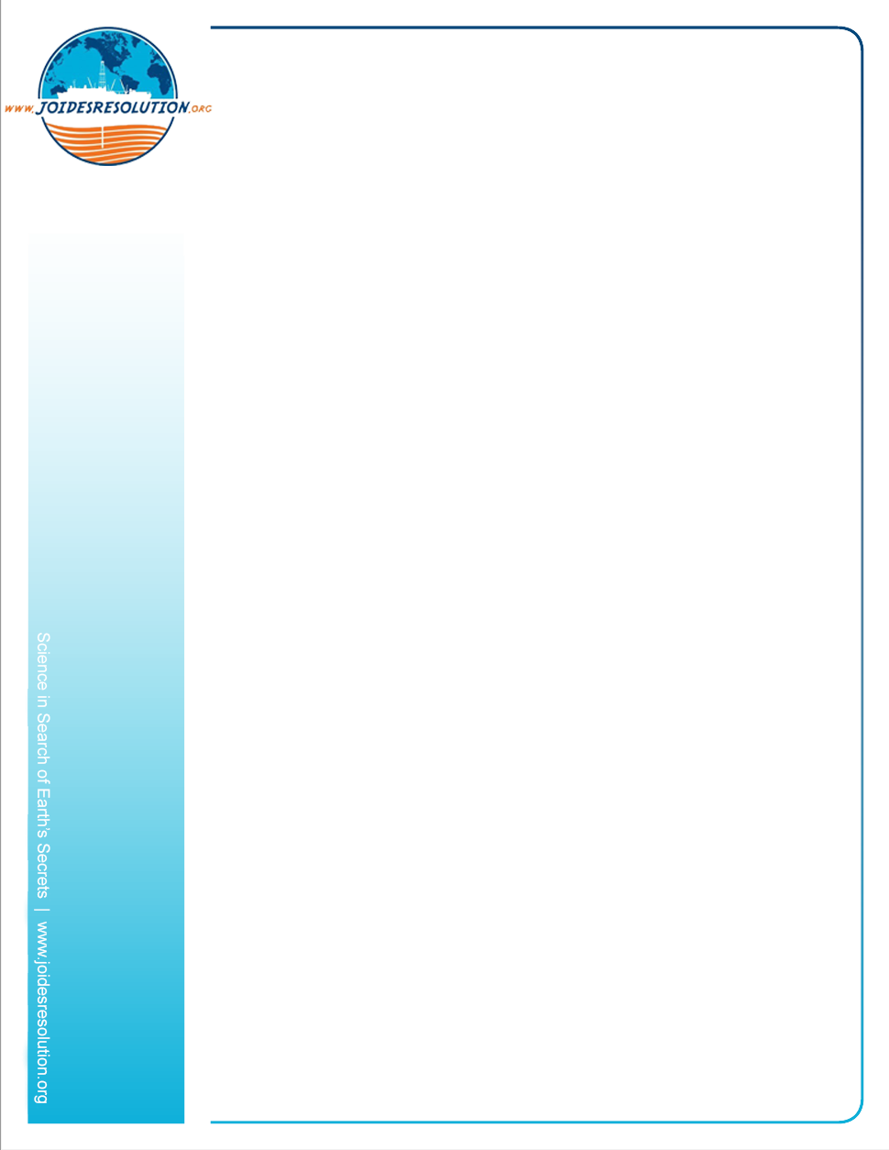
Podcast series “Casting into the Blue”
Ep. 1 – Interview with the Curator

Background
Casting into the Blue is a podcast series about the interesting jobs and people who are on board the JOIDES Resolution science vessel. This ship is one of the world’s few science drilling vessels and has been operating in every ocean round the globe since 1985. It drills into the ocean floor to collect and study core samples that help scientists better understand climate change, geology and Earth’s history.

Summary
Listen to our podcast interview with the JR’s Curator to find out what her job involves, and then answer the follow up questions found on the next page.

National Science Education Standards

Standard G: Science in personal and social perspectives

Target Audience
Ages 10 to 15
Grades 5 to 8

Time Required
Approximately 30 minutes.

Contents and Materials
https://soundcloud.com/joides-resolution/sets/casting-into-the-blue-careers-on-board-the-jr

- Laptop/smartphone with wifi
- Earphones
- Paper and pen

What to do:

- Before you start, write down what you think a Curator does.
- Write down three things you think the curator will talk about
- Listen to the podcast (10.31 minutes) then answer the following questions: https://soundcloud.com/joides-resolution/sets/casting-into-the-blue-careers-on-board-the-jr

Follow up listening comprehension questions

- What did the curator study before joining the JOIDES Resolution?
- Has she been a curator before?
- What type of vessels do you need to be able to go down to Antarctica?
- What did she study on her trips to Antarctica?
- What can sediments we get from under the ocean teach us?
- List what sea life she saw in Antarctica.
- What does a curator do on the JOIDES Resolution?
- What does the Curator do, alongside the technicians, once the scientists have their samples?
- Why do they refrigerate most of the samples?
- What is a typical day for a Curator? List the jobs they do:
- Where does the Curator work when the expedition ends? And who for?
- How many repositories are there around the world for the core samples that the JR collects by drilling? Where are they?
- How long have the cores been stored there?
- Who can request the samples within the first year of the expedition?

