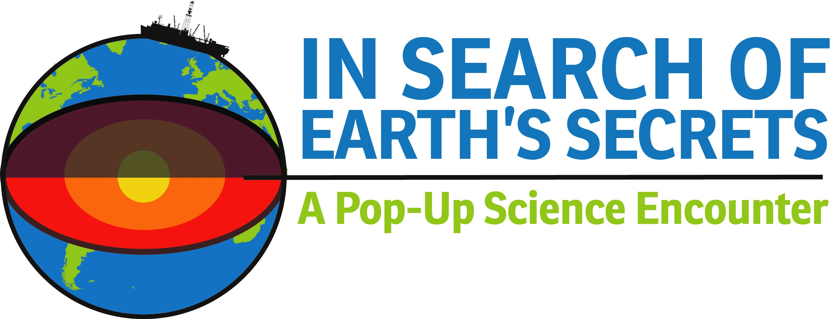
Funded by the National Science Foundation’s Division of Research on Learning (DRL),
NSF Award #1515856
Planning Information for Partner Organizations and Participating Communities
I. Project Background and Purpose: Much like missions to outer space, the deep-ocean expeditions of the NSF-sponsored ship JOIDES Resolution have the potential to ignite the imaginations of a whole generation of Americans—to engage thousands of people in the excitement of exploration, the process of science, and the people and tools required to get there. The JOIDES Resolution (“the JR”) is on a mission of scientific discovery into the unknown. What lies beneath all that water? What secrets about our planet’s development and ancient history can be revealed by sediments and rocks below? How can these explorations shed light on topics of great societal relevance, like climate change, the huge biosphere beneath the seafloor, and geo-hazards like earthquakes and tsunamis?
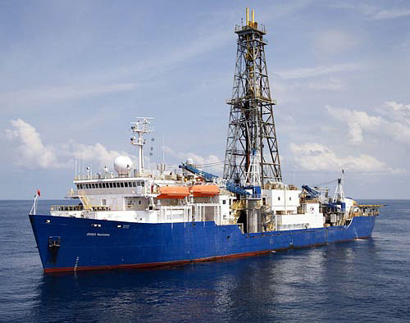
The JOIDES Resolution
As with space exploration, the JR’s research program requires extensive scientific collaboration and teams of engineers trying to reach highly inaccessible places in search of discoveries. The JR is one of the world’s largest research vessels and is the flagship vessel for the International Ocean Discovery Program, a multi-national research program dedicated to advancing scientific understanding of the Earth through drilling, coring, and monitoring the sub-seafloor. The United States has invested more than $1 billion in scientific ocean drilling over the past 12 years alone and generated key evidence for major scientific theories such as plate tectonics, extinction of the dinosaurs, and existence of life below the seafloor.
In Search of Earth’s Secrets uses the JR and her science to intrigue, engage, and inspire informal science audiences across the nation. The hypothesis of this project is that well-designed and facilitated “Pop-Up Blitzes” (“PUBs”) and Drill Down opportunities at museums and libraries in carefully selected locations will provide an effective mechanism for increasing STEM learning access among underserved minorities, rural populations and girls – and create a broadly applicable model for doing so in other science fields.

Our goals with the overall traveling exhibit are to:
- Increase access to and awareness of ocean/earth science and careers especially in disadvantaged communities, by bringing the activities, exhibits and scientists themselves to non-traditional venues ranging from block parties, local festivals, malls and parking lots to libraries, museums, and science centers).
- Create a sustainable model for STEM learning in informal environments.
- Increase interest in the scientific drilling and research activities of the JOIDES Resolution among the general public (children, teens and adults) who attend the PUBs and Drill Down events.
- Foster partnerships between educators and scientists that lead to broader dissemination of scientists’ research and the larger vision of NSF.

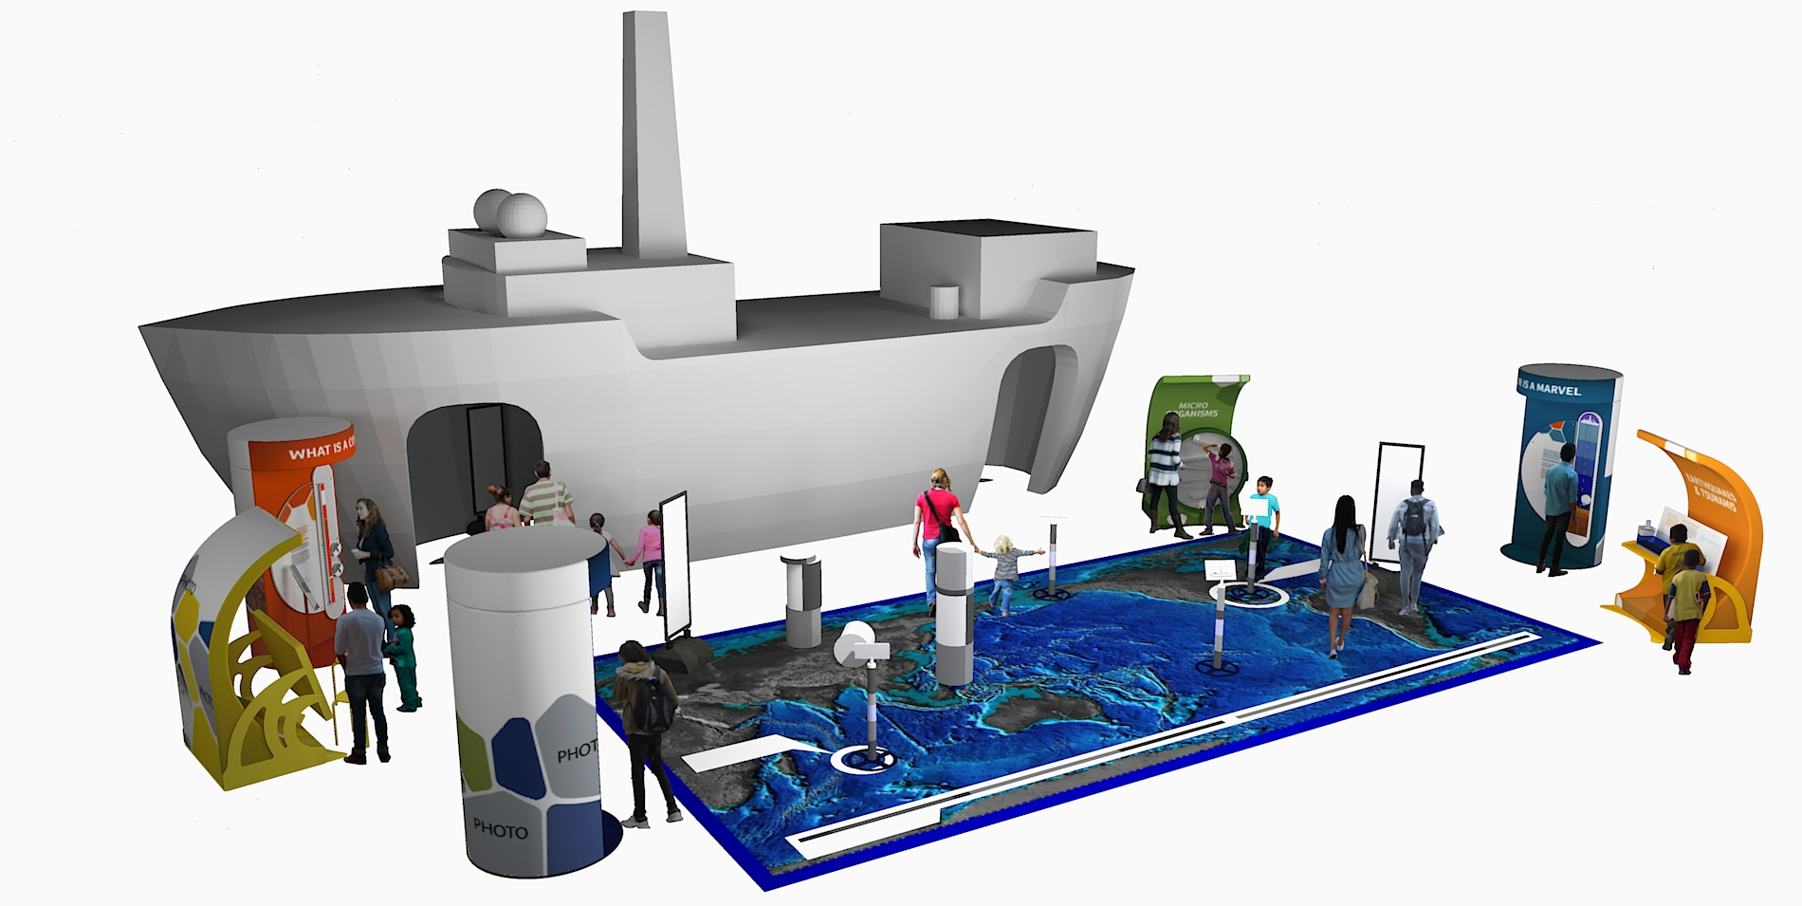
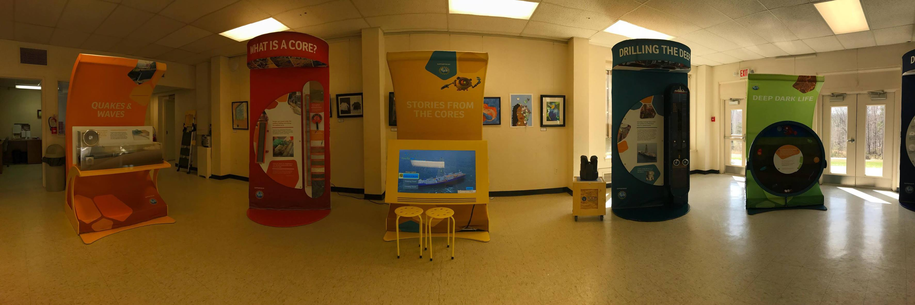

II. Project Partners: In Search of Earth’s Secrets is a collaboration between the Consortium for Ocean Leadership; the International Ocean Discovery Program; Lamont-Doherty Earth Observatory of Columbia University; Rutgers University; the University of Hawaii; and teams of community partners. The first three locations and teams (“Group 1”) are:
- Martinsville, VA: the Girl Scouts of Virginia Skyline Council, the Blue Ridge Regional Library, and the Virginia Museum of Natural History
- New Brunswick, NJ: the Girl Scouts of Central and Southern New Jersey, New Brunswick Free Public Library, and the Rutgers Geology Museum
- New York City: Partners in Queens and/or Brooklyn, NY
The project is also supported by a network of independent consultants and advisors in science education, exhibit design, and evaluation. The program expands upon earlier NSF-funded activities, including the Girl Scouts Ship to Shore Science Pilot Project.
III. Community Partners: As mentioned above, community teams consist of local representatives from these partners: a Girl Scout council or other youth-serving organization and a public library system and/or a museum or science center. Teams will work together to plan, facilitate, and evaluate the project locally, thereby contributing to a multi-year, national project. The sites listed in section 2 above are the first cohort (“Group 1”). Additional locations and teams will be added each year in through 2021 or beyond.
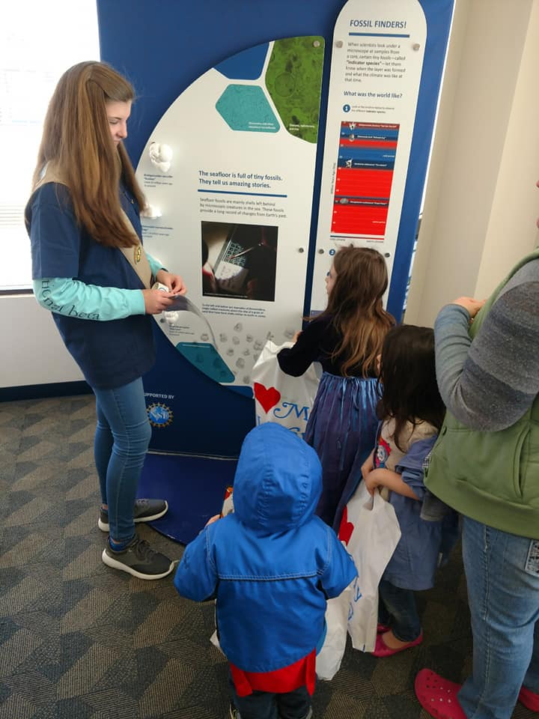
In selecting a representative for the team, partners should consider the overall scope and objectives of the project. Staff members will likely assist with basic programmatic and/or administrative aspects of the project. Each community team will send staff representatives to attend part or all of a 3-4-day planning and training meeting at Texas A&M University, at which teams will explore the exhibit components and have the opportunity to discuss and develop their initial plans for implementation in their respective communities, including coming up with appropriate schedules and event dates, and to meet with scientists and exhibit designers, provide feedback and ask questions. Travel and related training expenses will be covered by the grant.

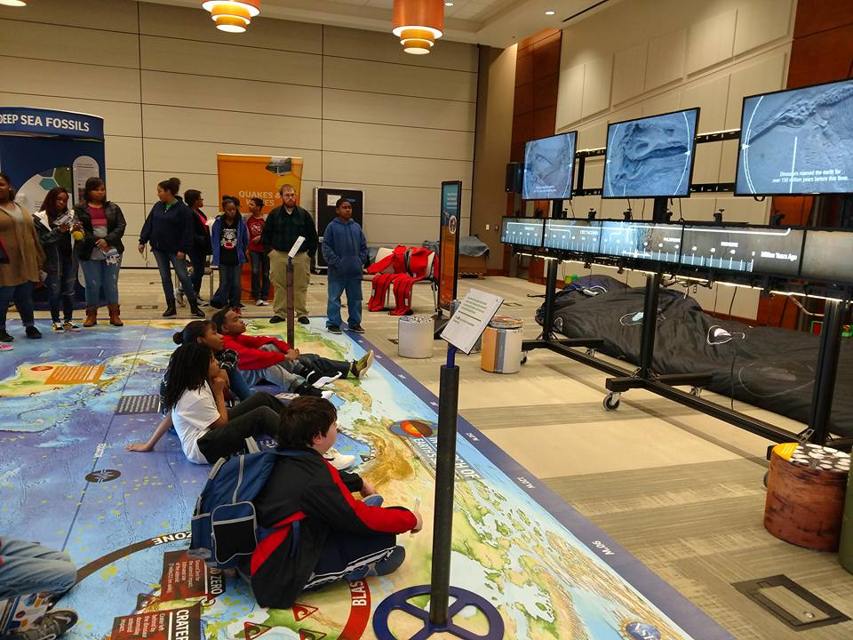
Back at home, each local team will work together to plan and implement the programs and events in their community. The project’s local contacts (Dennis Casey, Carrie Ferraro, and Karen Thomson, for Group I sites) will provide the necessary support to make the program a success, including organizing meetings, communicating with national program leaders, helping to facilitate all project needs and outcomes, and coordinating reports and evaluation instruments.
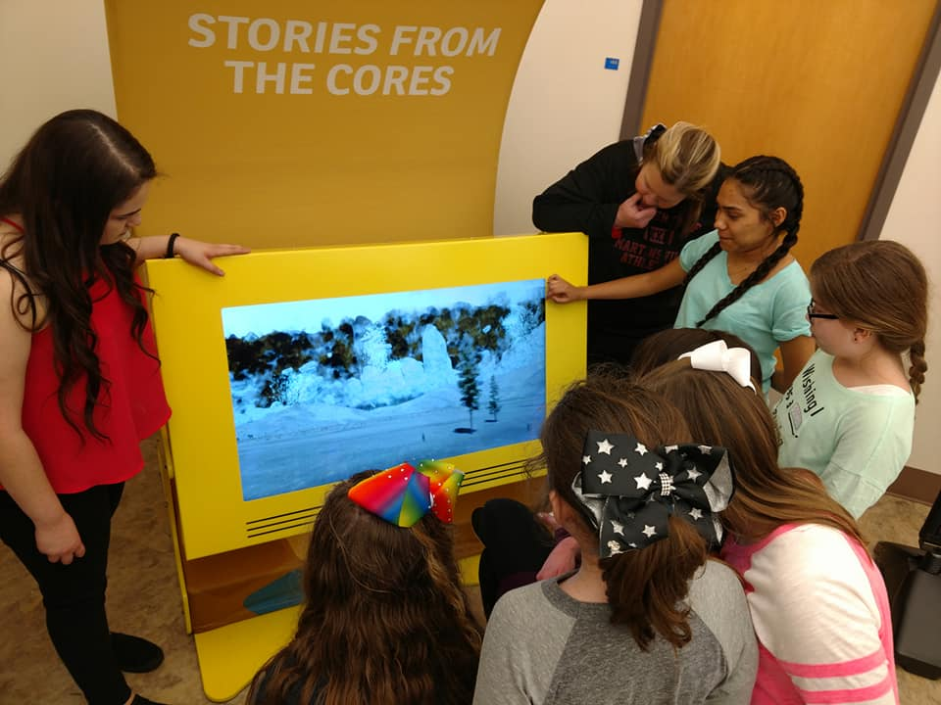
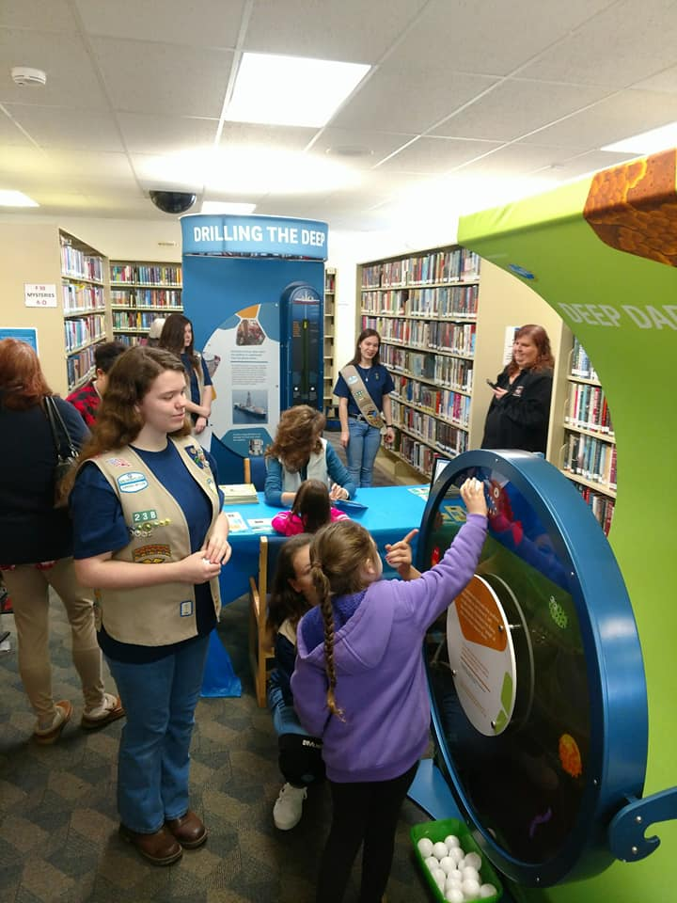
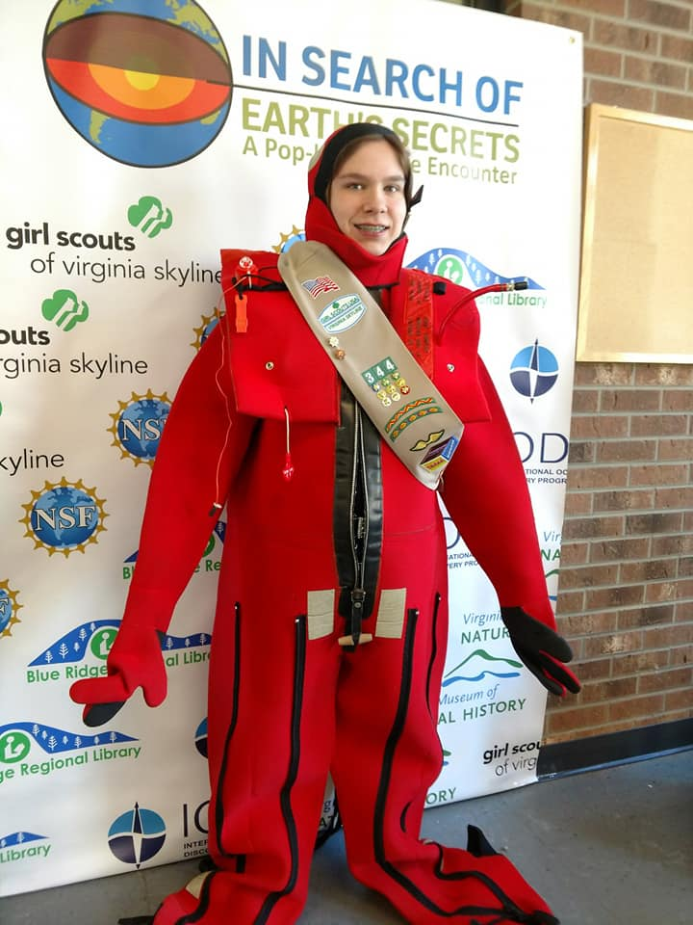

Each partnering Girl Scout council or youth organization will:
- Recruit approximately 35 teens to participate in a local STEM workshop series specifically for them, and collaborate in organizing the workshop series (identifying convenient dates and times, providing feedback, etc.) during the first year. Interested teens who participate will be encouraged and prepared to volunteer with the kiosks (learning stations) during the Pop-Up Blitzes (PUBs) and Drill Down events.
- Promote the workshop series, Pop-Up Blitzes, and Drill Down events within their council or chapter, including through the council’s alternative “pathways.”
- Identify a staff member or council volunteer as primary contact and send a representative to the multi-team planning workshop at TAMU.
Each partnering museum, library, and/or science center commits to:
- Assist in hosting and running the local workshop series for Girl Scouts/local teens and other volunteers who will help facilitate the kiosks during associated events.
- Host and display several of the earth and ocean science kiosks at one or more library branches or the informal science institution for part or all of a 4-8-week season of the program during each of two consecutive years.
- Assist in marketing and promoting the program to patrons and the community.
Funding There are funds in the project budget to support travel to the training at TAMU, stipends for team leaders from each partner institution, an intern, workshop supplies, and volunteers to assist during Pop-Up events. The project also provides for shipping the kiosks to the project sites and a rental van/truck for local transportation.
Evaluation and Optional Further Involvement All project teams will be involved in providing data that will be used in the analysis and evaluation of the overall project. What we learn together will help improve the program and contribute to the reports(s) that will be submitted to NSF. A small amount of funding will be available for activities at sites interested remaining involved after their first two years.

IV. Key Dates
Training for Group 1 Site Teams at Texas A&M: January 30 – February 2, 2018
Girl Scout/teen workshop series for Group 1 sites: during February– August 2018, during each site’s rotation
PUB/Drill Down at Group 1 sites:
February – April (Martinsville, VA
April – June (New Brunswick, NJ)
June – August (New York City, NY)
Formative evaluation of PUBs/workshop: ongoing
Second season of PUB/Drill Down at Group 1 sites: during Nov. 2018 – Oct. 2019
First year for Group 2 sites: Nov. 2018 – October 2019
First year for Group 3 sites: Nov. 2019 – October 2020

Questions?
Karen Thomson: kbt@servingpublicservice.net
Denny Casey: d.a.casey@comcast.net
Carrie Ferraro: ferraro@marine.rutgers.edu
Sharon Cooper: scooper@ldeo.columbia.edu

FAQs About In Search of Earth's Secrets: A Pop-Up Science Encounter
What are the specific exhibit topics? There are 6 interactive kiosks and a giant floor map to explore eight main themes: geology under the sea, the JOIDES Resolution as a STEM marvel, what is a seafloor core, volcanoes/tsunamis/earthquakes, climate change and microfossils, mass extinction of the dinosaurs, life below the seafloor, and stories from the cores (a 3-part interactive video game). In addition, a giant inflatable model of the JR contains a video-wall presentation that explores how science allows us to travel back in time and discover what happened in Earth’s past. The JR is a time machine that brings us there.

Who’s making all this? The exhibit design firm is LUCI Creative. ScienceMedia.nl produced the video presentation that plays inside the inflatable ship. Their work is informed by the scientists, educators and other members of the national project team.

What are the dimensions of the exhibit? When inflated, the “pop-up” ship is 45 feet long and 25 feet wide. Most of the ship is 12 feet high, except for a 30-foot high section that replicates the real ship’s drill tower. Each kiosk is 4 feet wide and seven feet tall when displayed. An interlocking floor map of the world’s oceans is 30 x 15 feet, and comprised of smaller sections that can be used in smaller spaces.
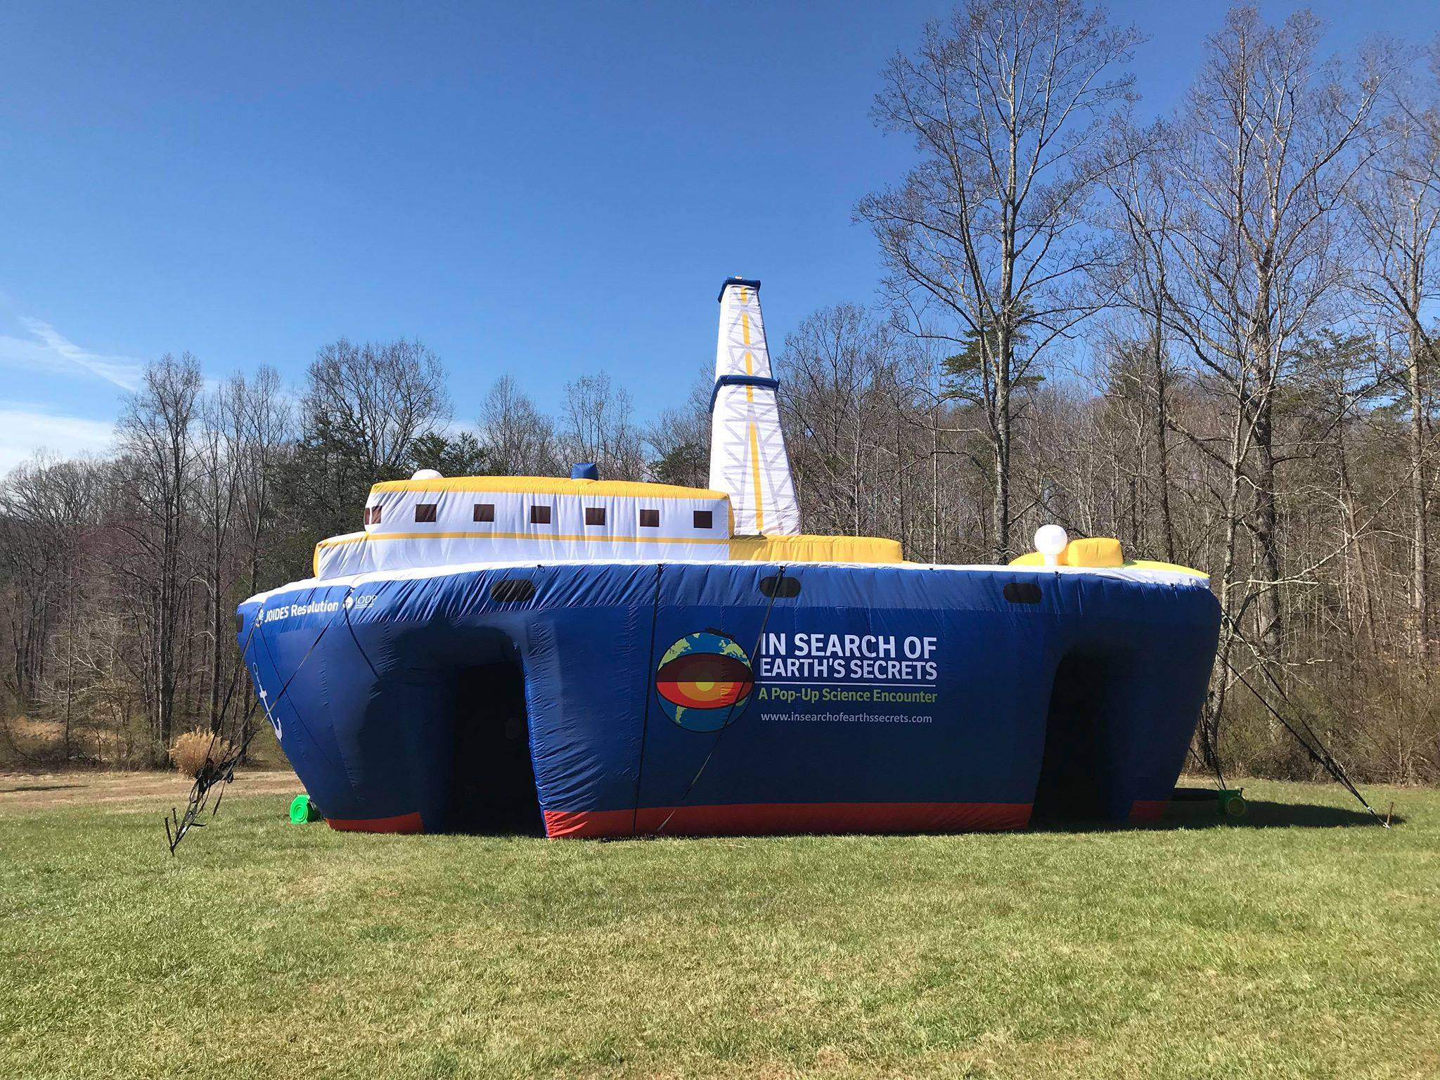
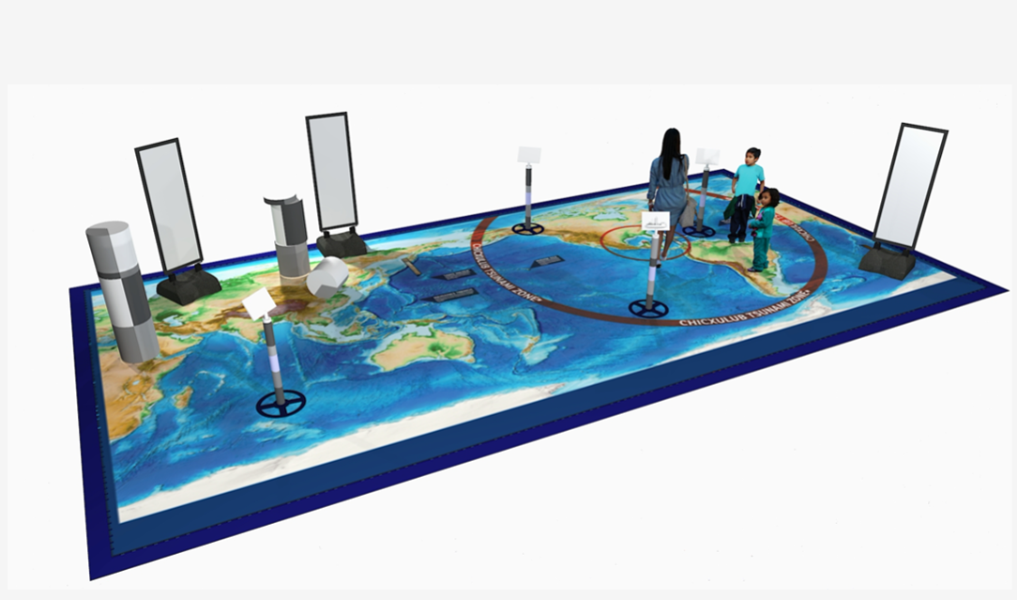
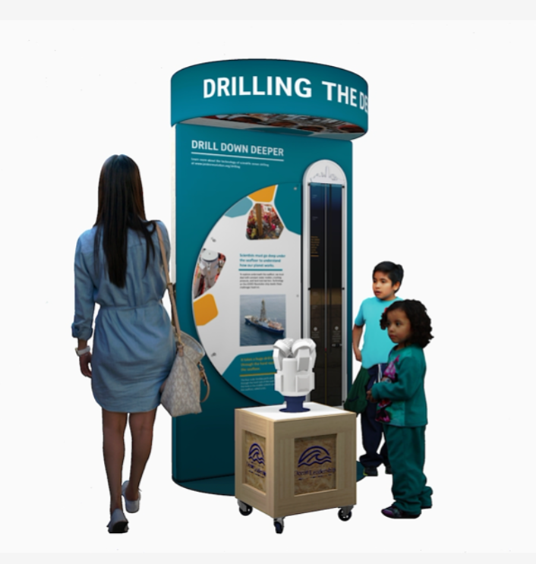

We don’t have enough space to display six kiosks inside our building! Can we still participate? We hope institutions can display all the kiosks, but understand that some sites may display some rather than all six, or perhaps display a few at a time. Communities with more than one host institution may also decide to display some in one host institution or branch and others at another. The inflatable ship is mostly for the outdoor events – we don’t expect hosts to display the 45-foot ship indoors, though it is possible if a large indoor space is available.
How is the “pop-up” vessel inflated and deflated? Much like a “bounce house.” The ship takes 10-15 minutes to inflate. Four blower fans run continuously. Two small generators power the fans. The ship deflates when the fans are shut off, and with help from people pushing the air out, takes about 45 minutes to fully deflate for packing up.
Does any equipment use gasoline? The generator runs on propane and gasoline, or if AC power is near-by can be plugged in instead. In that case, no generator would be needed.
Do the other outdoor displays or activities need electricity? One kiosk requires electricity, but the other five kiosks do not. There is a video wall installation to be shown inside the ship, which requires electricity, but this installation can be used with or without the ship. (The ship's interior has other graphics of interest, not just the video.) All of the power requirements for the exhibit (video wall, ship, one kiosk) can be run off the two generators that come with it.
Do you need a minimum area around the equipment used to inflate the vessel? Just walking distance around, but the ship does need to be tethered in some way if it is outside – either to water barrels, trees, vehicles, etc. Tent stakes and tether straps are included.
How is the vessel secured - are ropes or wires used to secure the vessel? Tether straps as noted above.
What are the kiosks made of, and how are they secured? The kiosks are made mainly of lightweight metal tubing, fabric, and plastic. They stand alone and do not need additional securing.
How is the exhibit stored? The inflatable ship packs down into one large “burrito” about 5 x 5 feet on its own pallet, plus a couple of small crates for the generator and blower. The kiosks and other exhibit components also fit into their own crates. Together, everything fits into a standard 26-foot rental truck.
How will we know how to do all this? Local team reps and project staff will have a chance to set up and take down the ship and kiosks during a national planning meeting this winter. One or more members of the national team will also be on site to help during the pop-up events, and some scientists and educators who have worked or studied aboard the real JOIDES Resolution research ship will be recruited to help facilitate events when needed during the time the exhibit is in your area.
How much room is needed to store the vessel between exhibit dates? See above. Some sites may choose to rent indoor storage space. During weeks before or after the exhibit rotates to a new community, the national team may also rent storage space. We will work with each site on storage solutions – if your facility has storage options, that would be great. But don’t let that deter you if you do not.
Will the exhibit be ADA-compliant, accessible to persons with disabilities? The designers are highly experienced and familiar with ADA guidelines. Everything is accessible to most.

Can a community team have the exhibit “pop-up” in more than one public outdoor space? Yes. The “pop-up” activities will take place on several days within each community, are designed to be compact enough to fit into a truck for transport, and to be easy to set up for a new day’s event. Some teams may decide to have the activities directly outside their building; others may go to parks, plazas, parking lots, block parties, festivals or different spots on different days, to “bring the exhibit to the people.”

Can more than one institution in the community host the “drill down” activities? Yes. Each site team must have at least one host institution and youth-serving organization, but some may have more.

Do visitors enter from one side of the ship, or can they enter from either “door”? There is one door we think of as the entrance to the pop-up ship and another as the exit. But individual sites can see how this evolves and be flexible as required.

Will local teams receive funding to participate? Primary partner organizations within each community team each receive a stipend of $5,000 for their first year (full modules) and $2000 for their second year (no need anticipated for training or youth workshop). Travel to the national planning meeting is also covered. If an organization serves as both the host institution and the teen program partner (such as a museum or library with its own teen docent or Saturday program), the organization will receive $5000 for each role.

How much will the teens be doing? Girl Scouts or other teens who participate in workshops will learn about the exhibit’s science topics and the exhibits themselves, before the days of the pop-up blitz. Teens in the workshops who want to volunteer can choose to sign up for one or more shifts to help out at the blitz or at the local museum or library that hosts the kiosks during the “drill down” weeks after the blitz.

How will evaluation work? As with any NSF-funded project, data collection about effectiveness is important. We’ll work with teams to keep evaluation as simple as possible! The national project team will handle much of this, in consultation with an external evaluation team. For example, at our pilot project's events a member of the project team was present and asked visitors to complete simply-worded, single-sheet surveys on site. A member of the national team will likely do this for at least one pop-up day in each community.

Surveys of staff and teens who participate will most likely be done via Survey Monkey, which reduces local hassle. We’re working to keep data collection simple throughout all phases of the project and will be happy to discuss this.

Items needed to be purchased/rented locally

Gasoline or propane for generator
Ballast water barrels if used

