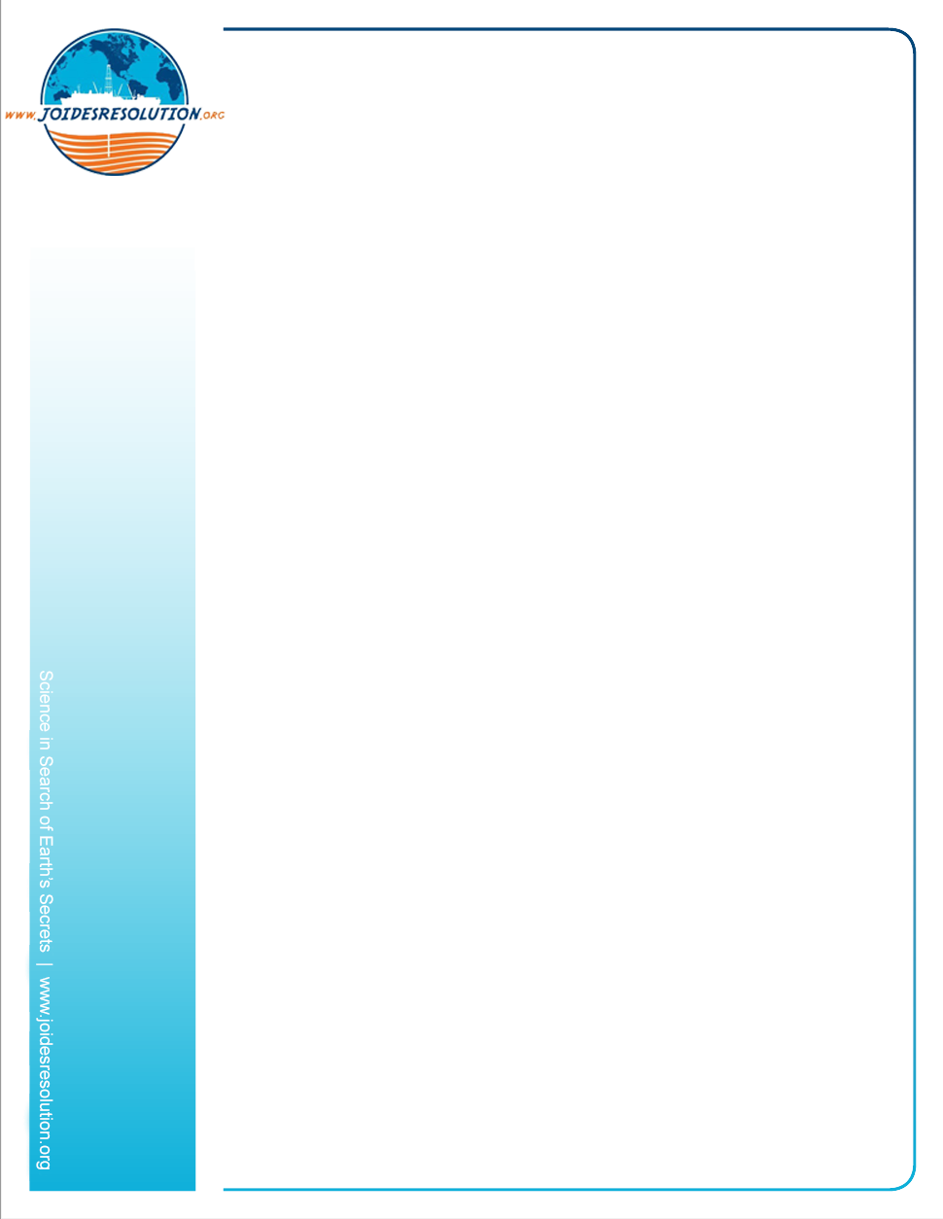
Podcast series “Casting into the Blue”
Ep. 1 – Interview with the Captain

Background
Casting into the Blue is a podcast series about the interesting jobs and people who are on board the JOIDES Resolution science vessel. This ship is one of the world’s few science drilling vessels and has been operating in every ocean round the globe since 1985. It drills into the ocean floor to collect and study core samples that help scientists better understand climate change, geology and Earth’s history.

Summary
Listen to our podcast interview with the ship’s Captain to find out what the job involves, and then answer the follow up questions found on the next page.

National Science Education Standards

Standard G: Science in personal and social perspectives

Target Audience
Ages 10 to 15
Grades 5 to 8

Time Required
Approximately 30 minutes.

Contents and Materials
https://soundcloud.com/joides-resolution/sets/casting-into-the-blue-careers-on-board-the-jr

- Laptop/smartphone with wifi
- Earphones
- Paper and pen

What to do:

- Before you start, write down what you think a Captain does.
- Write down three things you think the Captain will talk about
- Listen to the podcast (8.03 minutes) then answer the following questions: https://soundcloud.com/joides-resolution/sets/casting-into-the-blue-careers-on-board-the-jr

Follow up listening comprehension questions
- What was his role before he became the Captain?
- How long does he work on each expedition?
- Where in the world is the worst weather he has experienced on a vessel?
- Where on a ship is it the hardest place to sleep during a storm?
- What does he enjoy about being a Captain?
- What is the difference between each expedition?
- What did the crew see when the JR sailed into Gisborne?
- How many propellers does the ship have?
- How many thrusters do we have?
- What do the thrusters and the DP (Dynamic Positioning) system do?
- What did old drill rigs use to stay in place to drill for oil?

