Modeling the Rock Cycle

Background
The rocks that make up the Earth are constantly being recycled. One form of rock is often changed into another form of rock through certain processes of nature that occur over time.
In this activity, students will use Starburst candy, representing “rock”, to follow the pathways of the rock cycle, forming igneous, metamorphic, & sedimentary rock. JOIDES Resolution Expedition 376 traveled to Brothers volcano, which is one location where igneous rock can be found. Expedition 376 examined hard-rock cores retrieved from Brothers volcano, and this activity will allow students a glimpse into the formation of hard rock.

Summary
Students will model the rock cycle using Starburst candy and understand how rock may transform from one type to another. Students will also examine various types of rocks in follow-up activity.

National Science Education Standards
Standard B: Structure & Properties of Matter
Standard D: Geochemical Cycles

Ocean Literacy Essential Principles
Principle 2: The ocean and life in the ocean help shape the features of Earth.

Target Audience

Grades 9-12

Time Required

Approximately 90 minutes.

Contents and/or Materials
Starburst candies, heat source, aluminum foil and/or pans, rock samples, hand lenses and/or dissecting microscopes

Credits:
Tammy Orilio

Overview
The rocks that make up the Earth are constantly being recycled. One form of rock is often changed into another form of rock through certain processes of nature that occur over long periods of time. In this activity, students will use Starburst candy, representing “rocks”, to follow the pathways of the rock cycle, forming igneous, metamorphic, and sedimentary rock.
JOIDES Resolution Expedition 376 traveled to Brothers volcano, a hydrothermally active submarine volcano approximately 400km northeast of New Zealand, to examine the hard rock formed at this unique environment. This activity will allow students a firsthand glimpse into the formation of said hard rock. After completing the “candy” portion of the activity, students will visit different stations with rock samples and answer associated questions.

Learning Objective
Students will be able to identify & describe the 3 major rock types (igneous, metamorphic, & sedimentary) by modeling their formation and making observations.

Materials
Per group:
3 different colored Starburst candies
piece(s) of aluminum foil
small aluminum pie pans
hot plate
tongs
heat protecting gloves
kitchen scissors (or something to cut the Starburst with)
For Part 2: rock samples

Procedure- Part 1
- Take 3 different colored Starbursts and cut them into as many small pieces as you can. These small pieces are called sediment. Draw/write your observations in the sediments box on the rock cycle diagram.
- Pour one color layer of sediment onto your aluminum foil; spread it out to form a flat layer (but keep the pieces near/next to each other). Pour another color layer of sediment on top of the previous layer, and then repeat with your last color. Gently push the pieces of sediment together so they all form into one large piece. Draw what you observe in the sedimentary rock box on the rock cycle diagram.
- Fold the foil over the top of the layers of sedimentary rock, wrapping it like a birthday gift. Warm the package in your hands for ~3 minutes; press down on it as much as you can. You are trying to soften the rock a bit, to form it into metamorphic rock. Draw what you observe in the metamorphic rock box on the rock cycle diagram.
- Place your metamorphic rock into the aluminum pie plate, and bring the plate to the hot plate. Heat the pie plate for ~2-3 minutes the goal is to fully melt the candy, but NOT SCORCH IT. While the candy is still melting on the heat, draw what you observe in the magma box on your rock cycle diagram.
- Once all the candy is fully melted, remove the pie plate from the heat using either tongs or gloves. Let it cool. Observe how the newly formed rock looks different from the previous rock. Draw what you observe in the igneous rock box on your rock cycle diagram.

- Brothers volcano/plate tectonics extension: at this point, teacher can lead a discussion about formation of Brothers volcano at a convergent plate boundary, with magma (melted Starburst) being pushed up through a fissure in the crust and building up in shape.

Clean up: peel igneous rock off the pie plate, throw away candy, wash out plate for reuse. Any other aluminum foil pieces will be properly disposed of.

Analysis & Conclusion Questions
- We turned sedimentary rock into metamorphic rock in steps #3 & 4. Can you think of a way that sedimentary rock could be changed into igneous rock without going through the metamorphic stage?
- You’re (hopefully) starting to see that any form of rock can be changed into any other form of rock. How could a rock be changed, but still be classified as the same form of rock?
- Describe what the melted rock (magma) looked like, and the final appearance of the igneous rock. Compare it to the metamorphic and sedimentary rock.
- What type of rock do you think forms from erupting volcanoes?
- Which rock type is formed from broken-down pieces of rock? How do you think these pieces harden into rocks in nature?
- Based on this activity, describe the rock cycle in your own words.
- Of the three rock types investigated, which one would most likely contain identifiable fossils? Support your answer.
- Expedition 376 did not have a paleontologist on board to date the rocks based on microfossil assemblages- why do you think this is? (HINT: think about it in terms of the rocks present at Brothers volcano)

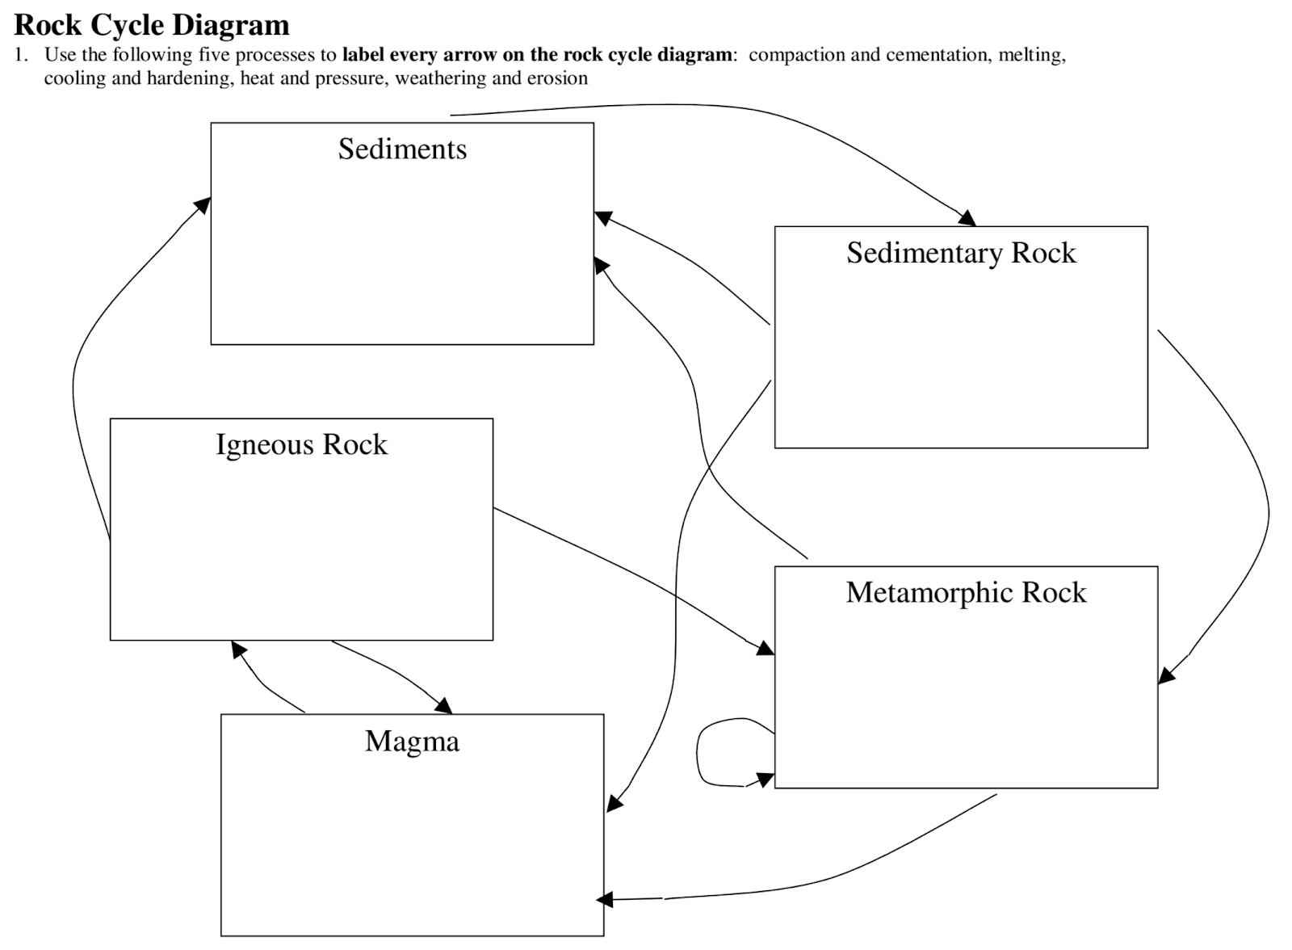

Part 2: Rock Samples

Teacher Info:
Students will be working their way through 3 different rock stations. At each station, there’s a colored sheet for students to pick up & complete. Students will examine different rock samples, which will need to be numbered beforehand (so they don’t get mixed up).

If you do not already have rock samples, they can be ordered from:
https://www.amazon.com/American-Educational-Classroom-Collection-Minerals/dp/B005QDPZ6U (for the majority of rocks needed)
https://www.amazon.com/Scott-Resources-Piece-Sedimentary-Rock/dp/B00FGELX4M/ref=sr_1_2?s=industrial&ie=UTF8&qid=1529223673&sr=1-2&keywords=coquina
(for coquina + other sedimentary rocks)

You’ll also need hand lenses and/or dissecting microscopes for detailed inspection of rock samples

IGNEOUS ROCKS
TEACHER TIP: print on red or pink paper, since igneous = “fire” rocks

Read the following information, examine the rocks, and then answer the questions:

Igneous rocks form directly from magma that has cooled. Depending on its location, the magma will cool at different rates.

If the magma remains deep underground, then it will cool slowly for perhaps as long as a million year. A large pool of magma that cools deep underground is called a pluton. When the magma cools over a long period of time, the crystals in the magma will have a chance to grow quite large. Igneous rocks that form deep underground are called intrusive igneous rocks or plutonic rocks.

When magma cools on the surface, it is called lava. Lava will cool quickly to form extrusive or volcanic igneous rock.

- Compare granite (#x) and rhyolite (#x). Use a hand lens or dissecting scope to examine.
  - Which has larger crystals?

  - Which cooled on or near the surface?

  - Which is the extrusive igneous rock?

- Compare basalt (#x) and gabbro (#x). Use a hand lens or dissecting scope to examine.
  - Which has smaller crystals?

  - Which cooled deep in the ground?

  - Which is an intrusive igneous rock?

- Look at scoria (#x) and pumice (#x). Use a hand lens or dissecting scope to examine.
  - Any crystals in these igneous rocks?

There shouldn’t be any crystals in scoria and pumice because they are pyroclastic igneous rocks, which means they’re like fireworks out of a volcano!
METAMORPHIC ROCKS
TEACHER TIP: print on dark paper, since they form deep underground

Read the following information, examine the rocks, and then answer the questions:

Metamorphic rocks are “changed rocks’. They come from parent rocks that have been altered by heat and/or pressure deep underground. The composition of the parent rock doesn’t change, but the size and shape of the crystals will. Metamorphic rocks can form near subduction zones and near plutons.

- Fill in the following chart with the information that is asked in the questions below.
Parent Rock Metamorphic Relative

- Compare the parent rock sandstone (#x) with the metamorphic rock quartzite (#x). Which has larger crystals? **answer #2-4 in the chart above**

- Compare the parent rock limestone (#x) with the metamorphic rock marble (#x). Which has larger crystals?

- Metamorphic rocks are usually more foliated than their parent rocks. This means that the crystals are more flattened or stretched. Compare oil shale (#x) and slate (#x). Which is more foliated? Which is the parent rock and which is the metamorphic rock?
*Oil shale it’s part of the fracking business. If you were to squeeze that rock really hard, oil would come out (well, not you, but machines + chemicals).

Other Questions: *answer here, NOT in chart

- Heat and/or pressure change parent rock into metamorphic rock. What does the parent rock become if it is weathered and then eroded and formed into a rock?
- Heat and/or pressure change parent rock into metamorphic rock. What does the parent rock become if it’s totally melted and then re-cools?

SEDIMENTARY ROCKS
TEACHER TIP: print on blue paper, since these rocks often form in aquatic systems

Read the following information, examine the rocks, and then answer the questions:

In general, sedimentary rocks form from sediments or particles that have been transported and deposited in water. There are many ways to group sedimentary rocks: clastic, evaporate, and organic are some of the sub-groups.

Clastic sedimentary rocks are composed primarily of broken pieces or clasts of older weathered and eroded rocks that are “glued” together with silicate or calcite. Particles can range in size from boulders to pebbles to dust-sized, even to atomic levels. Take a look at the box of sedimentary rocks. What three (3) rocks represent clastic sedimentary rocks?

- _____________________ 2. ______________________ 3. _______________________

The size of the particles in sedimentary rock indirectly tells you the location of deposition. It takes a lot of energy to move pebbles compared to the energy required to move dust. A river must have lots of energy to move pebbles & boulders, but to move smaller particles, the river can just meander along. In the ocean, small dust-sized particles will travel far from the coastline before they sink to the ocean floor. Pebbles, on the other hand, will deposited closer to shore.

Of the above rocks you listed, which do you think was found farthest from shore? __________________
Closest to shore? ________________

One sub-group of sedimentary rocks are the organics, which formed from plant or animal parts. Coquina (#x) is made of compressed visible seashells. Check it out under the dissecting scope.

Bituminous coal (#x) is composed of compressed and partially changed plant parts. It contains trace amounts of mercury (Hg), arsenic (As), cadmium (Cd), lead (Pb), selenium (Se), and uranium (U). Because coal is burned in such large quantities (to produce electricity), even trace amounts add up to large quantities being released into the atmosphere. The 1990 Amendments to the U.S. Clean Air Act identify 189 hazardous air pollutants, 18 of which are associated with coal! We’ll talk more about coal in our energy and air pollution units.

Another sub-group of sedimentary rocks is called the evaporites. These sedimentary rocks formed when a lake or shallow ocean dried up, leaving miniscule precipitates behind. Halite (#x) (made from sodium chloride) and gypsum (#x) (made from magnesium chloride) are examples of evaporite sedimentary rocks.

