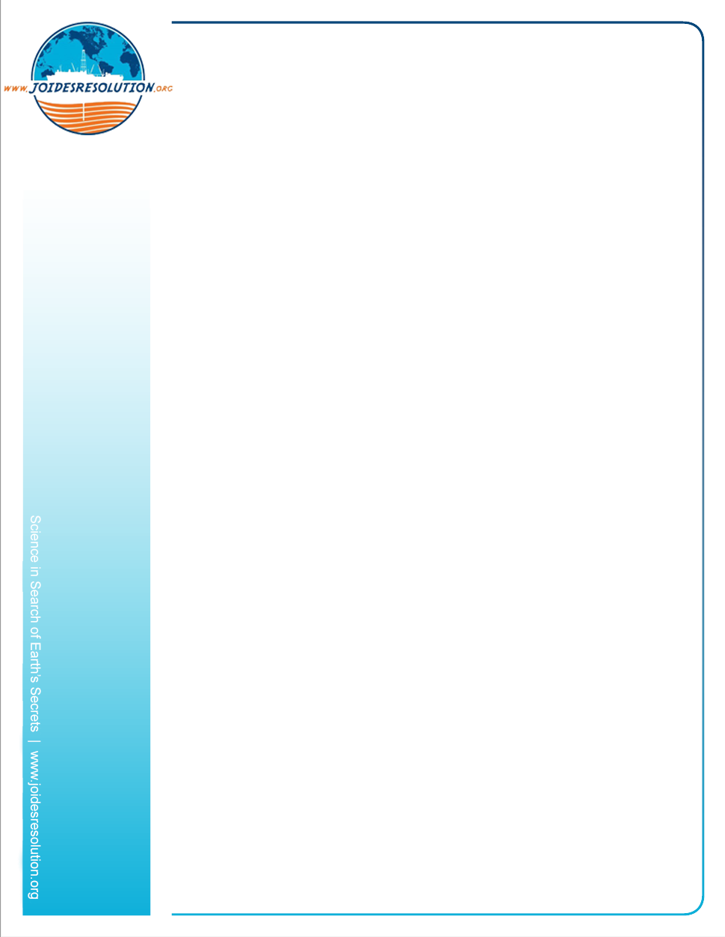
Volcanoes, Vents, & GIFs
A 5E Lesson Plan

Background
Volcanoes can form in 3 different tectonic settings: at subduction zones, at rift zones, and at hot spots. We will be examining all three settings as they relate to volcano creation, with a focus on Brothers volano, the site of IODP Expedtion 376. Hydrothermal vents may be associated with both rift and subduction zones, and result from the interaction of seawater and hot magma associated with submarine volcanoes.

Summary
This activity follows the 5E format, allowing students to learn about the topic(s) using a variety of methods, ranging from teacher-directed learning, to student creation, to assessment.

National Science Education Standards
Standard D: Energy in the Earth System; Geochemical Cycles
Standard E: Understandings About Science & Technology
D

Ocean Literacy Essential Principles
Principle 2: The ocean shapes the features on Earth.
Principle 5: The ocean supports a great diversity of life and ecosystems.
Principle 7: The ocean is largely unexplored.

Target Audience
Grades 10-12

Time Required
Approximately 150 minutes.

Contents and/or Materials
For creating GIFs: small whiteboards, dry erase markers, modeling clay

Credits:
Tammy Orilio
Overall Objectives: SWBAT
- Describe how Brothers volcano was formed
- Identify two OTHER types of volcanic creation (different from Brothers’ process)
- Describe how hydrothermal vents are formed

Step 1: ENGAGE
Start lesson by doing a Think-Pair-Share with partner, and write answers on small whiteboards at each desk.
- Where does the heat from a volcano come from?
- At what type of plate boundary do volcanoes form?
- What is a hydrothermal vent system?
- List any vocabulary words you already know pertaining to volcanoes & hydrothermal vents.
Next, show the YouTube video “Plate Tectonics Explained” (2:37) www.youtube.com/watch?v=kwfNGatxUJI
This will allow students to check their answers, and provide the class with a short review of plate tectonics topics.

Step 2: EXPLORE
To deepen understanding, students will use web resources to answer the following questions:
- How are plate boundaries related to volcanoes?
- Describe the three (3) main ways that volcanoes are created.
- Describe what a hot spot is and how a volcano forms there. Are hot spots associated with plate boundaries? Explain.
- Describe what a spreading center is, what type of boundary it occurs at, and how a volcano forms there.
- Describe what subduction is, what type of boundary it occurs at, and how a volcano forms at a subduction zone.
Websites to use: (others may be added to the list, or you may choose to not use this list at all)
- www.tinyurl.com/m45ef4f
  - Original URL: http://pbs.panda-prod.cdn.s3.amazonaws.com/media/assets/wgbh/ess05/ess05_int_volcanintro/01_Where.htm
- www.tinyurl.com/yb2zxon5
  - Original URL: https://kamu.pbslearningmedia.org/resource/ess05.sci.ess.earthsys.tectonic/tectonic-plates-earthquakes-and-volcanoes/#.Wx_lzzNKii4
- www.geology.sdsu.edu/how_volcanoes_work/Volcano_tectonic.html

Step 3: EXPLAIN
To ensure that students have accurate information, the teacher will present on the topic(s) via a Powerpoint, and students will take notes (fill-in-the-blank outline provided). This PPT may also be pre-recorded (on a site such as Screencast-o-matic or Camtasia) and notes completed at home, for a flipped classroom scenario.

Step 4: ELABORATE
Students will now practice with their understanding of the formation of hydrothermal vents and volcanoes by creating their own animated GIF products. Working in groups of 2-3, students will illustrate the various concepts they’ve learned regarding volcano and hydrothermal vent formation. Directions on separate page.

Step 5: EVALUATE
To assess for final comprehension, students will answer short-response questions as individual assessment. Questions on separate page below.

Step 3: EXPLAIN
GUIDED NOTES:
Volcano formation, plate tectonics, and hydrothermal vents

Guiding Questions (you should be able to answer these when we’re finished with notes)
- What processes form volcanoes?
- Where are volcanoes located, relative to tectonic plate boundaries?
- What processes form hydrothermal vents?

What is a volcano?
• A cone-shaped hill/mountain; often with a __________________________ at the summit
• Formed around a crack in the crust that releases __________________________

Theory of Plate tectonics
• __________________ (outermost layer) of Earth is divided into segments called plates; plates ride on top of plastic ___________________ (part of upper mantle)

As the magma in the asthenosphere moves, so do the plates

Convergent boundaries
Which is more dense, oceanic crust or continental crust? Why?

- The MORE DENSE ________________slides under the LESS DENSE _______________ at a ________________ zone, entering the asthenosphere
- What happens to the crust at this point?

- The melted material ________________________________, forming volcanoes
• Notable examples of volcanoes formed at subduction zones:

DIVERGENT BOUNDARIES
- On land, ________________ form when two ________________ plates diverge
- In the ocean, ________________________ form when two ___________ plates diverge
  - How does a volcano form at a divergent boundary?

- Notable examples of volcanoes formed at divergent boundaries:

Volcanoes and Hot Spots
- What is a HOT SPOT? = area of mantle that’s _______________________________
- Higher temps cause magma to __________, breaking through crust and adding layers to eventually form a volcano
  - Notable examples of volcanoes formed at hot spots:

Hydrothermal vents
- Created when seawater seeps into _______________ in crust, and is ______________
- Heated seawater reacts with rocks in crust, which changes its chemistry
- Hydrothermal fluid that’s released from hot springs has high metal content → WHY?

- How are the characteristic “chimneys” build at hydrothermal vents?

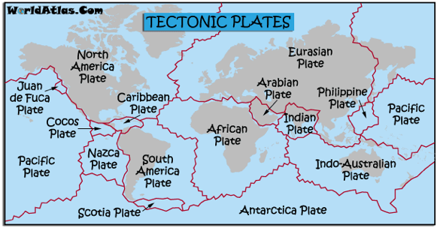

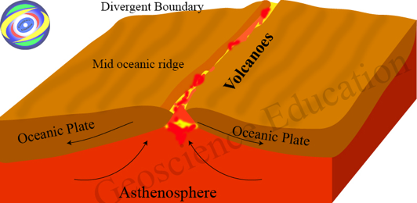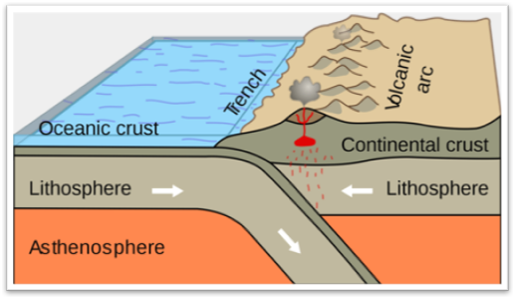

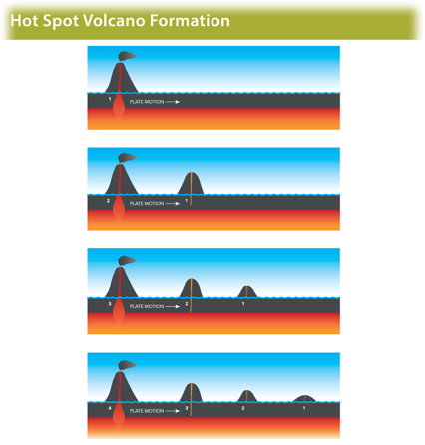

Step 4: ELABORATE

Group Project – Make a GIF to illustrate formation of volcanoes & hydrothermal vents
50 POINT QUIZ GRADE

Create 2 different GIFs -- you may choose any two from the following list:
- Subduction zone at Brothers volcano/island arcs (subduction process leading to volcano formation)
- Hot spot formation and volcano creation over a hot spot (also include how the volcano(es) change over time)
- Divergent boundary and volcano formation (mid-ocean ridge)
- Formation of hydrothermal vents (starting with seawater) including chimney creation

You can draw on paper or on dry erase boards (I prefer dry erase so we won’t use as much paper). You could use clay to make models that move a bit for each frame. Take pictures on a smart phone of each stage of your illustration, then use an online GIF maker to create the final product. Consider how the pictures flow together – background, angle of photo, etc.

A good GIF-making website is www.imgflip.com but you can choose another one if you’d like.

Examples from bio class, some better than others: https://imgflip.com/gif/1fldzg , https://imgflip.com/gif/1fle9v (notice the background in this one→ really distracting!) , https://imgflip.com/gif/1fljzd

Email each GIF itself or a link from your GIF-creation-website to _____________________________ and to each group member. Put the topic of your GIF as the email subject and include the names of group members in the email text.

Grading for each of the two GIFs is as follows:
10 points – content is correct/informative/interesting
5 points – Six to ten frames included in the GIF animation.
5 points – aesthetics – neat drawings/models, consistent angle/background so images flow together well, speed slow enough to be able to understand what is happening in each frame but fast enough to flow together.
5 points – on time, followed directions for submitting final product via email – subject, names in text, copy team members.

Step 5: EVALUATE

Answer in complete sentences on your own paper.

- Hot spots can be used to determine the speed of plate movement. Describe what information and measurements (at least 2 things) would you need to calculate the rate of movement.
- Hawaii’s hot spot doesn’t display the typical relationship between volcanoes & plate boundaries, yet it does provide evidence of plate tectonics. How?
- Japan, Indonesia, and the Philippines are examples of volcanic island chains that have formed along subduction zones between plates in the western Pacific.
  - Describe what happens when two tectonic plates collide along a subduction zone.
  - Explain how subduction leads to volcanic activity.
- In 1977, Dr. Robert Ballard discovered a strange and bountiful world of life in the deep Pacific Ocean near the Galapagos Islands. Abundant life was found in close proximity to hydrothermal vents, and it came as quite a surprise to many biologists, who thought that life in the deep ocean was rather scarce. It’s now assumed that life can be found anywhere on the deep ocean floor wherever there is heat and hydrogen sulfide, which is the compound needed to initiate the food web at these light-deprived communities. Using the information above, let’s pretend you are the captain of a ship transporting plutonium across the Atlantic Ocean to supply a European country with fuel for nuclear power plants. Shortly after leaving port in NYC, your ship is hijacked by pirates who plan on taking the plutonium to a different country across the Atlantic in order to make nuclear weapons. As captain, you must make a decision to help save the world. You consider dumping the plutonium in the ocean as the lesser of two evils, rather than it get delivered for weapon-making. Now, you must decide where in the Atlantic to dump the plutonium. You want to dump it where there is the least likelihood of bountiful life, and you know there’s perhaps plentiful life where there are hydrothermal vents, which in turn are found near where the ocean crust is rather thin and magma is near the ocean floor.
  - Here’s the question: Would you dump the plutonium
      - ¼ or ¾ of the way across the Atlantic from the east coast of North America/west coast of Europe & Africa ….. Or …..
      - ½ of the way across the Atlantic, at about the midline of the Atlantic Ocean?
Choose one of the two options and explain why you chose that answer in reference to the relationship between deep ocean life and plate tectonics.

